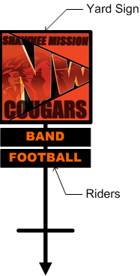**SMNW- Yard Sign Order Form**

Sales benefit SMNW PTSA

- **Yard Sign -** $**50.00 / Each**

18” x 18” all weather PVC sign with steel

t-bar stake

- **Riders - $10.00/ Each**

3” x 18” PVC

Riders are available for any school activity & screw onto stake

**Circle All Riders ordering or write in other category in blank space**

|  |  |  |  |  |  |
| --- | --- | --- | --- | --- | --- |
| Band | Club 121 | Forensics | Latin Club | Spanish Club | Volleyball |
| Baseball | Coalition | French Club | NHS | Spanish NHS | Wrestling |
| Basketball | Cougar Classics | German Club | Newspaper | Spirit Club | Yearbook |
| Bowling | Cougar Express | Golf | Orchestra | STUCO | Class of 2020 |
| BPA | Cross Country | Gymnastics | Photojournalism | Swim & Dive | Class of 2021 |
| CCC | Debate | Jazz Ensemble | Quill & Scroll | Tennis | Class of 2022 |
| Cheer | DECA | Key Club | Soccer | Thespian Troupe | Class of 2023 |
| Choir | Football | KUGR | Softball | Track & Field |  |

Customer’s Name:________________________ Student’s Name:_________________

Address:_______________________________________________________________

Phone #:__________________________ Email:______________________________

**Make Checks payable to: SMNW PTSA**

**ORDER INFORMATION**

Signs _____ ea x $50.00 = $_____

Riders _____ ea. x $10.00 = $_____

TOTAL AMOUNT ENCLOSED $______

Check Number ___________

**Deadline for ordering is Sept. 26, 2019**

Send order form and payment to:

SMNW Signs c/o PTSA

12701 W. 67th St.

Shawnee , KS 66216

or send to NW office w/student